
TRIBHUVAN UNIVERSITY

Faculty of Institute of Science and Technology

MADAN BHANDARI MEMORIAL COLLEGE
ANAMNAGAR, KATHMANDU


LAB PRACTICAL REPORT
For
Geographical Information System (CSC409)
8th semester Lab Report submitted in the partial fulfillment of the requirements for the degree of Bachelor of Science in Computer Science and Information Technology

Under the supervision of
Madhusudan Adhikari

Submitted by:
Ayushmi Adhikari (T.U. Symbol No: 29136/078)

Submitted to:
Department of Computer Science and Information Technology

- Introduction
Geographic Information Systems (GIS) have become an essential technology for collecting, managing, analyzing, and visualizing spatial and geographic data. GIS integrates hardware, software, and geographic data to capture, store, manipulate, analyze, and display information that is spatially referenced to the Earth. By combining spatial data with attribute data, GIS enables users to understand relationships, patterns, and trends that may not be easily recognized through traditional data analysis methods.
In recent years, GIS has been widely used in many fields such as urban planning, environmental management, disaster risk assessment, transportation planning, resource management, and demographic studies. Governments, researchers, and planners rely on GIS tools to support decision-making processes by providing accurate spatial information and visual representations of geographic phenomena.
Nepal, with its diverse geography and rapidly changing urban environment, can benefit significantly from GIS-based spatial analysis. Population growth, urban expansion, infrastructure development, and environmental challenges require effective spatial planning and monitoring. GIS provides an efficient platform to analyze these spatial patterns and support sustainable development planning.
This assignment focuses on the practical application of GIS techniques using ArcGIS software. The project involves the creation of a geodatabase, processing administrative boundary data, integrating demographic information, and analyzing spatial relationships between geographic features. Various spatial datasets such as administrative boundaries, population statistics, and thematic layers are utilized to demonstrate common GIS workflows used in real-world applications.
The study also involves georeferencing a topographic map sheet, which allows scanned maps to be aligned with real-world coordinates. This process helps verify the spatial accuracy of vector datasets and ensures that different geographic datasets can be correctly overlaid and analyzed together. In addition, thematic spatial layers such as roads, land use, settlements, and water bodies are used to create meaningful geographic visualizations.
One of the important objectives of this project is to demonstrate how demographic information, such as population statistics, can be integrated with spatial data to produce informative maps. By calculating population density and population change across municipalities, the project helps visualize population distribution patterns and demographic changes over time.
Overall, this assignment provides hands-on experience in GIS data management, spatial analysis, and cartographic visualization. The use of geodatabases, geoprocessing tools, georeferencing techniques, and Model Builder workflows demonstrates how GIS can be applied to organize and analyze geographic information efficiently. The final outputs of this project include thematic maps and spatial datasets that illustrate key geographic and demographic characteristics of the selected study area.

- Objectives
The main objective of this GIS assignment is to apply Geographic Information System techniques for spatial data management, analysis, and visualization using ArcGIS software. The project aims to demonstrate how spatial and non-spatial data can be integrated to produce meaningful geographic information and maps.
The specific objectives of this project are as follows:
- To create a GIS workspace and file geodatabase for organizing spatial data.
- To process administrative boundary data and extract municipality and district boundaries.
- To collect and integrate municipality-wise population data with spatial layers.
- To georeference a topographic map sheet using ArcGIS tools.
- To download and process thematic GIS layers such as roads, land use, and water bodies.
- To analyze spatial data and verify spatial accuracy using the topographic map.
- To prepare thematic maps showing population density, population change, and general geographic features.

- Study Area
The study area selected for this project is Kathmandu District, which lies in Bagmati Province of Nepal. Kathmandu is the capital district of the country and serves as the political, administrative, economic, and cultural center of Nepal. Due to rapid urbanization and population growth, Kathmandu district has become one of the most densely populated areas in the country.
Kathmandu District consists of several municipalities including Kathmandu Metropolitan City, Budhanilkantha Municipality, Tokha Municipality, Nagarjun Municipality, Chandragiri Municipality, Dakshinkali Municipality, Shankharapur Municipality, Gokarneshwor Municipality, Tarkeshwor Municipality, and Kageshwori Manohara Municipality.
The district is located in the Kathmandu Valley, which is surrounded by hills and contains a mixture of urban settlements, agricultural land, forests, rivers, and transportation networks. The Bagmati River and its tributaries flow through the district and play an important role in the region’s geography and drainage system.
Kathmandu has experienced significant population growth over the past decades due to migration, economic opportunities, and urban development. This makes it an important area for spatial analysis of population distribution and urban expansion.
For this GIS project, the municipality boundaries and district boundary were extracted from administrative spatial datasets. Population statistics for municipalities were integrated with spatial data to analyze demographic patterns. The study area provides a suitable example for applying GIS techniques such as spatial data processing, georeferencing, thematic mapping, and spatial accuracy verification.

- Data Sources
Several spatial and non-spatial datasets were used to complete this GIS project. The datasets were obtained from reliable online sources and processed using ArcGIS software.

Administrative Boundary Data
Administrative boundary data of Nepal, including district and municipality boundaries, was obtained from the National Geoportal of Nepal. This dataset was used to extract the municipal boundaries of the selected district and to generate the district boundary layer.
Source:
https://nationalgeoportal.gov.np

Population Data
Municipality-wise population statistics for the selected district were collected from the City Population database. The dataset included population values for the years 2011 and 2021, which were used to analyze population distribution and population change.
Source:
https://www.citypopulation.de

Topographic Map Sheet
The topographic map sheet covering the study area was downloaded from the Nepal Topographic Map Archive. The map sheet was later georeferenced in ArcGIS to align it with spatial datasets and verify spatial accuracy.
Source:
https://pahar.in/nepal-topo-maps

OpenStreetMap Thematic Layers
Additional thematic GIS layers such as roads, settlements, land use, water bodies, and waterways were downloaded from the Geofabrik OpenStreetMap data repository. These datasets were used for spatial analysis and map preparation.
Source:
https://download.geofabrik.de/asia.html

- Methodology
The methodology of this project involved several steps of spatial data preparation, processing, analysis, and visualization using ArcGIS software. The workflow followed the sequence of tasks provided in the assignment instructions. The process began with setting up the GIS workspace and geodatabase, followed by administrative boundary processing, population data integration, georeferencing of the topographic map sheet, thematic layer extraction using ModelBuilder, spatial accuracy verification, and finally thematic map preparation.
5.1 Workspace and Geodatabase Preparation
The first step of the project involved creating a well-organized GIS workspace to manage all spatial datasets and outputs efficiently. A project folder structure was created to store downloaded datasets, geodatabases, screenshots, and final maps.
Within ArcGIS, a File Geodatabase was created to store all spatial data in a structured format. The geodatabase was named according to the required naming convention:
Kathmandu_KathmanduMetro_29136
Inside the geodatabase, a Feature Dataset was created using the appropriate projected coordinate system used for Nepal. This feature dataset was named after the selected district.
All spatial vector datasets processed during the project were stored inside this feature dataset to ensure consistency and proper organization of the data. This included layers such as:
- Kathmandu_District
- Kathmandu_Municipalities
- Road_Kathmandu
- Water_Kathmandu
- Waterways_Kathmandu
- Landuse_Kathmandu
- Places_Kathmandu
Raster datasets such as the downloaded topographic map sheet (Kathmandu_topo.jpg) were also added into the ArcGIS project for reference and spatial comparison.
This structured geodatabase helped maintain a clean workflow and ensured that all spatial layers used in the analysis shared the same coordinate reference system.

5.2 Administrative Boundary Data Processing
Administrative boundary data for Nepal's local government units was obtained from the National Geoportal of Nepal. The dataset containing the boundaries of all municipalities and rural municipalities in Nepal was downloaded and added into ArcGIS as a shapefile named NepalLocalUnits0.
The dataset initially contained boundaries for all districts and municipalities across Nepal. Therefore, it was necessary to extract only the administrative units belonging to Kathmandu District.
The Split By Attribute geoprocessing tool was used to separate the local units based on the district attribute. This operation created individual layers for each district. From these outputs, the municipalities belonging to Kathmandu District were selected and stored as a new layer named:
Kathmandu_Municipalities
After extracting the municipality boundaries of the district, the Dissolve tool was applied to merge all municipality polygons into a single boundary representing the entire district. This process created a new layer named:
Kathmandu_District
This dissolved layer represents the overall administrative boundary of Kathmandu District and was used later as the clipping boundary for thematic spatial layers.
All processed layers were stored inside the feature dataset within the project geodatabase to maintain proper organization and spatial consistency.
5.3 Population Data Collection and Integration
Municipality-wise population data for Kathmandu District was collected from the City Population database, which provides demographic statistics for Nepal's local government units.
The population data was downloaded and organized using Microsoft Excel. The dataset was cleaned and formatted to ensure that the municipality names exactly matched the attribute names present in the Kathmandu_Municipalities layer within ArcGIS. This step was important to ensure that the attribute join could be performed successfully.
The Excel dataset contained the following fields:
- District – Name of the district
- Municipality – Name of the municipality
- Status – Type of municipality (Metropolitan, Municipality, etc.)
- Pop2011 – Population recorded in the 2011 census
- Pop2021 – Population recorded in the 2021 census
The Excel file was then imported into ArcGIS and added as a table layer. Using the Join tool, the population table was joined with the Kathmandu_Municipalities spatial layer using the Municipality name field as the common attribute.
After the join operation was completed, the population attributes became part of the municipality spatial dataset. This allowed the population data to be used for spatial analysis and thematic mapping.
Two additional calculated fields were later created in the attribute table:
Pop_Density – representing population density for each municipality
Pop_Change – representing the population change between 2011 and 2021
These fields were used for thematic map preparation.
5.4 Topographic Map Sheet Processing
A topographic map sheet covering the Kathmandu region was downloaded from an online Nepal topographic map archive. The downloaded map file was added to ArcGIS as a raster image named:
Kathmandu_topo.jpg
Initially, the raster image did not contain spatial reference information. Therefore, the Georeferencing tool in ArcGIS was used to align the map with the spatial datasets already present in the project.
The georeferencing process involved identifying recognizable geographic features on the topographic map and matching them with the same locations on the GIS layers. Control points were created at several locations such as:
- Road intersections
- River crossings
- Settlement locations
- Municipal boundary intersections
Multiple control points were added across different parts of the map to improve the alignment accuracy. As additional control points were added, ArcGIS adjusted the position of the raster map to match the coordinate system of the project.
After the alignment appeared satisfactory, the Update Georeferencing option was used to save the spatial reference information permanently. The georeferenced map was then used as a reference layer to visually compare other spatial datasets.

5.5 Thematic Layer Download and ModelBuilder Processing
Additional spatial datasets were required to represent thematic geographic features such as transportation networks, land use patterns, water bodies, and settlements. These datasets were downloaded from the Geofabrik OpenStreetMap (OSM) data repository, which provides free GIS data derived from OpenStreetMap.
The downloaded datasets included the following layers:
- Roads
- Land use
- Places (settlements)
- Water bodies
- Waterways
Since the downloaded datasets contained spatial information for the entire country of Nepal, it was necessary to extract only the features that fall within Kathmandu District.
To automate this process, a ModelBuilder workflow was created in ArcGIS. ModelBuilder allows multiple geoprocessing operations to be combined into a single automated workflow.
Within the ModelBuilder environment, the Clip tool was used to clip each thematic layer using Kathmandu_District as the clipping boundary.
Each layer was processed as follows:
- Roads layer clipped to create Road_Kathmandu
- Water body layer clipped to create Water_Kathmandu
- Waterways layer clipped to create Waterways_Kathmandu
- Land use layer clipped to create Landuse_Kathmandu
- Places layer clipped to create Places_Kathmandu
The resulting layers contained only the spatial features located within Kathmandu District. All clipped layers were stored inside the district feature dataset within the geodatabase.

5.6 Spatial Accuracy Verification
After processing the thematic layers, the spatial accuracy of the data was visually verified by comparing the clipped vector layers with the georeferenced topographic map (Kathmandu_topo.jpg).
The comparison focused on examining the alignment of important geographic features such as:
- Road networks
- Rivers and water bodies
- Settlement locations
The Road_Kathmandu layer was compared with the road network visible on the topographic map to check whether major roads and intersections aligned correctly.
Similarly, the Water_Kathmandu and Waterways_Kathmandu layers were compared with rivers and streams shown on the topographic sheet.
The Places_Kathmandu layer was compared with settlement locations and towns represented on the map.
Minor positional differences were observed in some locations. These discrepancies may be due to differences in mapping scale, data collection methods, or updates in geographic features over time. However, overall spatial alignment between the processed vector layers and the topographic map was found to be reasonably accurate.

5.7 Map Preparation and Visualization
The final stage of the project involved preparing thematic maps to visualize demographic patterns and geographic features within Kathmandu District.
First, population density was calculated for each municipality. A new field named Pop_Density was created in the attribute table of the Kathmandu_Municipalities layer. Population density was calculated using the 2021 population values and the area of each municipality.
The results were visualized using graduated color symbology, where darker colors represented higher population density and lighter colors represented lower density values.
Next, population change between 2011 and 2021 was calculated by creating a field named Pop_Change. This value was calculated by subtracting the 2011 population from the 2021 population for each municipality. The results were visualized using thematic classification to highlight municipalities experiencing greater population growth.
Finally, a general purpose district map was prepared using the Layout View in ArcGIS. This map included several important geographic layers such as:
- Administrative boundaries (Kathmandu_District and Kathmandu_Municipalities)
- Transportation network (Road_Kathmandu)
- Land use features (Landuse_Kathmandu)
- Water bodies and rivers (Water_Kathmandu and Waterways_Kathmandu)
- Settlement locations (Places_Kathmandu)
To produce a complete and professional map layout, essential cartographic elements were added including:
- Map title
- Legend
- North arrow
- Scale bar
- Data source information
- Coordinate grid
These maps provide a visual representation of the demographic and geographic characteristics of Kathmandu District and form the final outputs of the GIS project.

- Results and Discussion
The GIS processes in this project produced well-organized and meaningful spatial datasets for the selected district. Each step was carefully executed in ArcGIS to ensure accuracy and proper integration of data.
Geodatabase and Feature Dataset:
The first step was creating a structured geodatabase to store all spatial data. A Feature Dataset was created inside the geodatabase, which kept all vector layers organized and ensured that all datasets used the same coordinate system.
Administrative Boundaries:
Using the administrative boundary data from the National Geoportal, municipality boundaries of the selected district were extracted using the Split by Attribute tool. Then, the Dissolve tool was applied to combine these into a single district boundary layer. This helped focus analysis on the study area and simplified further processing.
Population Data Integration:
Population data for all municipalities was collected from the City Population website, cleaned in Excel, and joined to the municipality boundary layer in ArcGIS. After joining, the Pop2011 and Pop2021 columns appeared in the attribute table, allowing analysis of population distribution and changes over time. This integration made it possible to prepare maps showing population density and population change for the district.
Topographic Map Georeferencing:
The topographic map sheet covering the municipality was georeferenced using control points. Points such as road intersections and landmarks were matched between the raster map and vector layers. After georeferencing, the topographic map aligned well with the vector datasets, providing a reliable reference for checking spatial accuracy.
Thematic Layers and ModelBuilder:
Thematic layers including roads, land use, settlements, water bodies, and waterways were downloaded from OpenStreetMap. Using ModelBuilder, these layers were clipped using the district boundary. This automated process saved time and ensured that all layers matched the study area perfectly.
Spatial Accuracy Check:
By comparing the vector layers with the georeferenced topographic map, it was observed that roads, settlements, and rivers were mostly aligned correctly. Minor differences were noted in some areas, likely due to variations in data sources or map scales.
Maps and Visualization:
The final outputs include maps for population density, population change, and a general-purpose district map showing roads, land use, water bodies, and settlements. These maps clearly show spatial patterns of population and geographic features, which can help in planning and decision-making.
Summary:
The project successfully demonstrates the use of GIS to organize data, join population statistics, georeference maps, process thematic layers, and produce informative maps. The workflow shows how GIS can help understand the spatial distribution of population and other geographic features in a district.

- Conclusion
This GIS project demonstrates the practical application of ArcGIS for spatial data management, analysis, and visualization. By creating a structured geodatabase and organizing vector and raster layers, the project ensured efficient handling of all spatial datasets.
The integration of municipality-wise population data with spatial boundaries allowed the calculation of population density and population change, highlighting demographic patterns across the district. Georeferencing the topographic map ensured accurate alignment of vector and raster datasets, while thematic layers such as roads, settlements, land use, and water bodies provided a complete spatial context for the study area.
The resulting maps and analyses show that GIS is a powerful tool for understanding spatial relationships, supporting planning, and visualizing geographic and demographic information. Overall, this project illustrates the importance of GIS in decision-making, urban planning, and resource management, while providing hands-on experience in standard GIS workflows.

- References
- National Geoportal of Nepal. (2023). Local Units Administrative Boundaries of Nepal. Retrieved from https://nationalgeoportal.gov.np
- City Population. (2023). Nepal: Population of Districts and Municipalities 2011–2021. Retrieved from https://www.citypopulation.de
- Pahar.in. (2023). Nepal Topographic Maps. Retrieved from https://pahar.in/nepal-topo-maps
- Geofabrik. (2023). OpenStreetMap Data for Nepal – Thematic Layers. Retrieved from https://download.geofabrik.de/asia.html

- Annex (Screenshots of Major GIS Steps)

Screenshot 1: Geodatabase and Feature Dataset
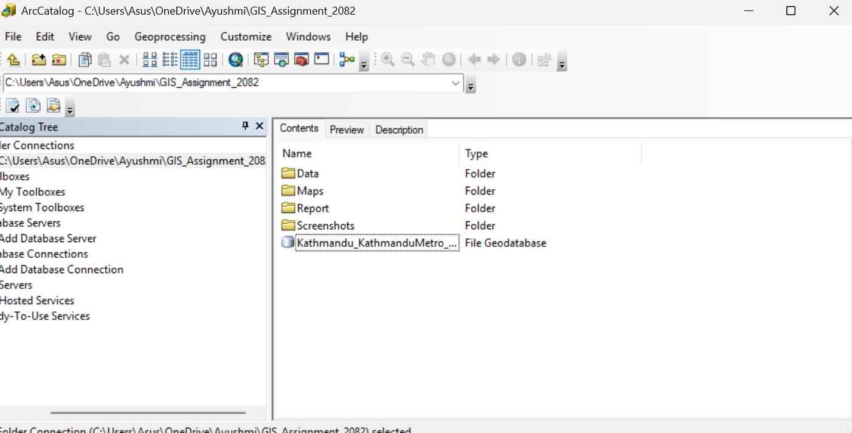
Description: Shows the File Geodatabase created for the project and the Feature Dataset inside it, where all vector layers are stored.

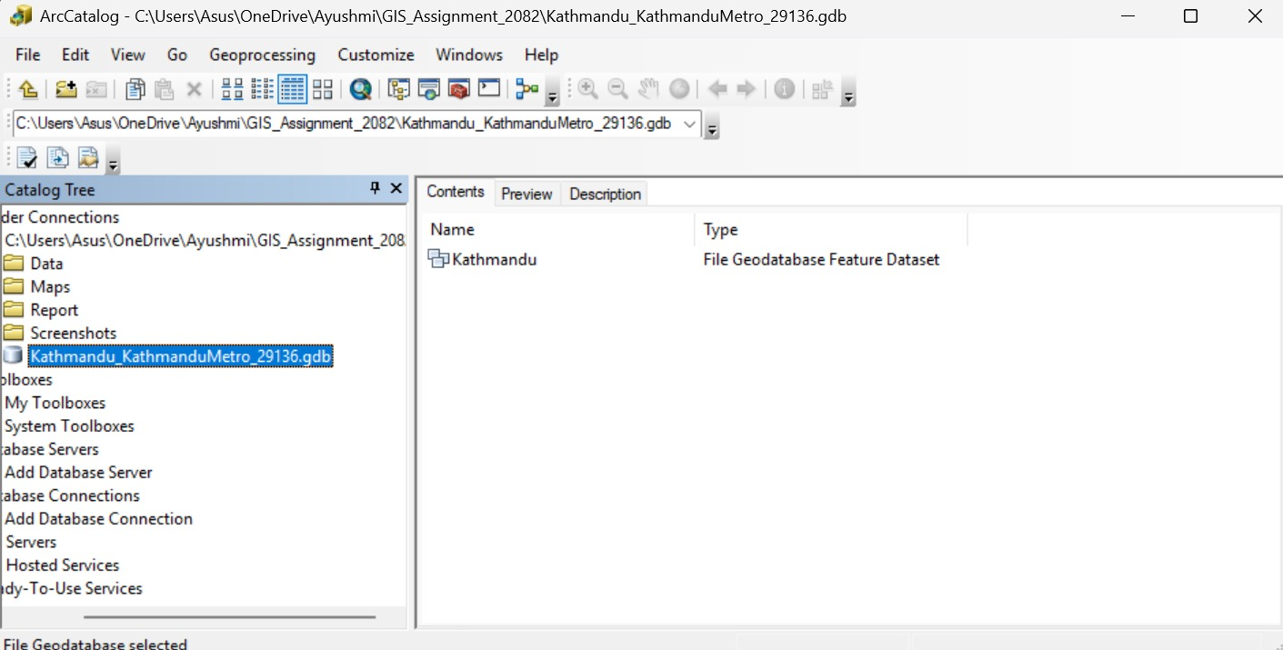

Screenshot 2: Split by Attribute (Municipality Extraction)
Description: Demonstrates the extraction of municipality boundaries from the Nepal Local Units dataset using the Split by Attribute tool.
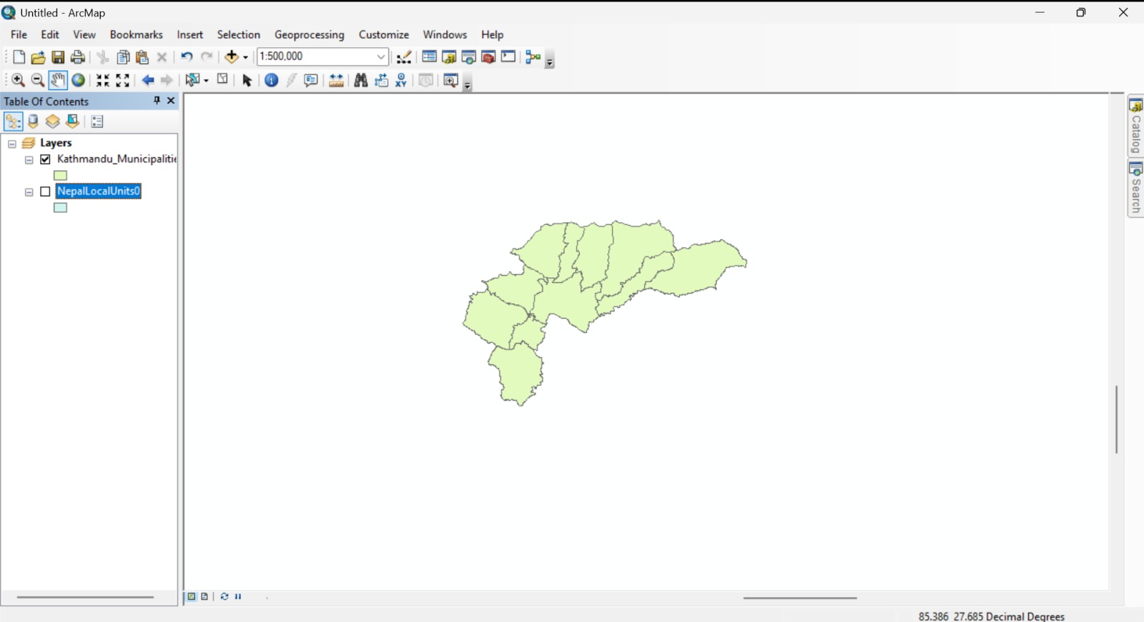
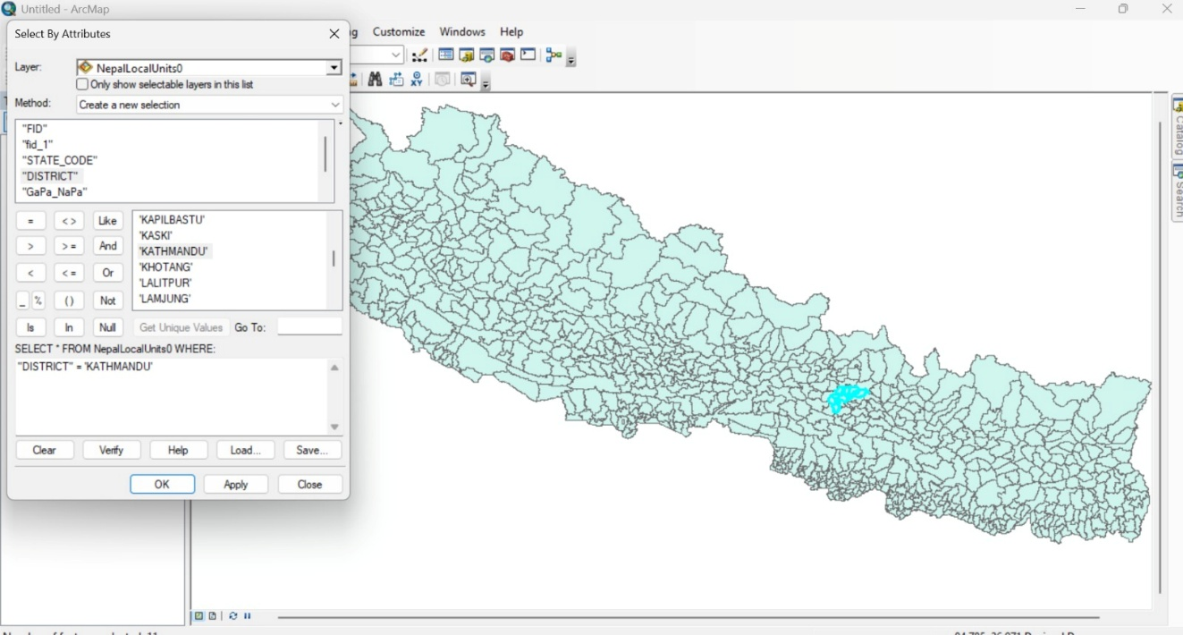

Screenshot 3: Dissolve (District Boundary)
Description: Shows the creation of the district boundary layer by dissolving municipality boundaries.
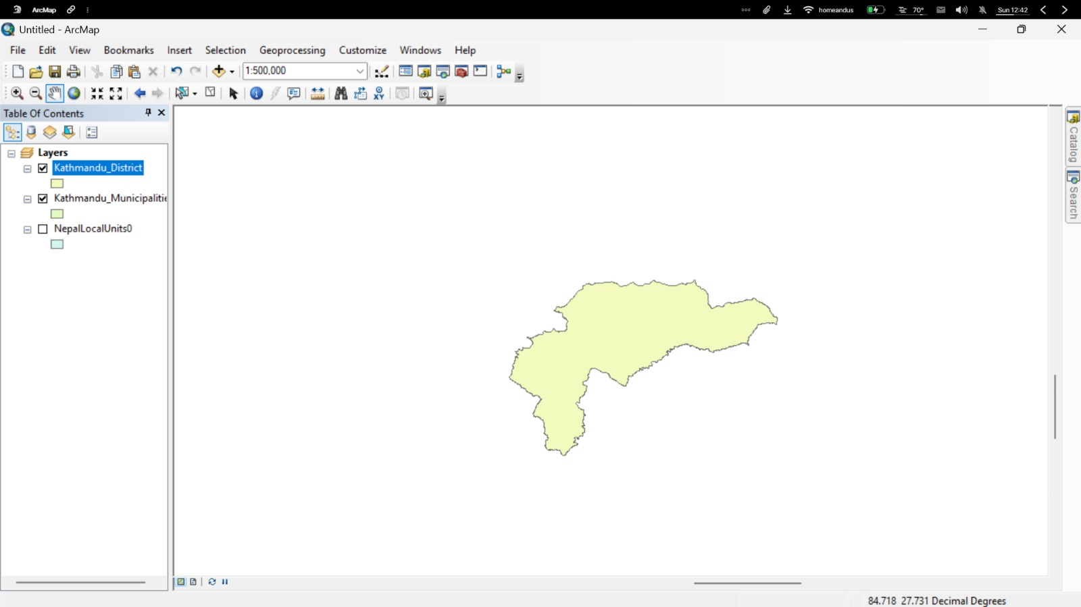
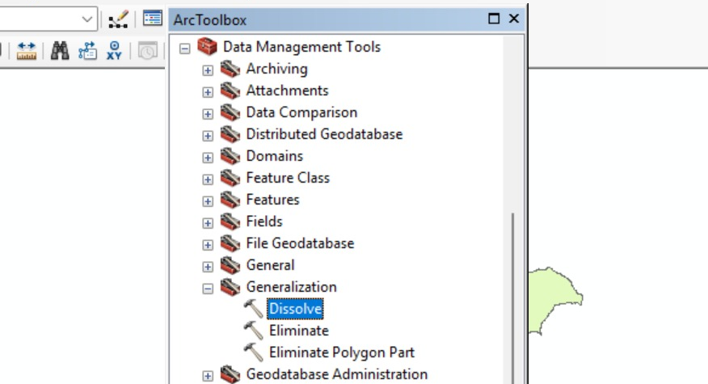

Screenshot 4: Population Table in Excel
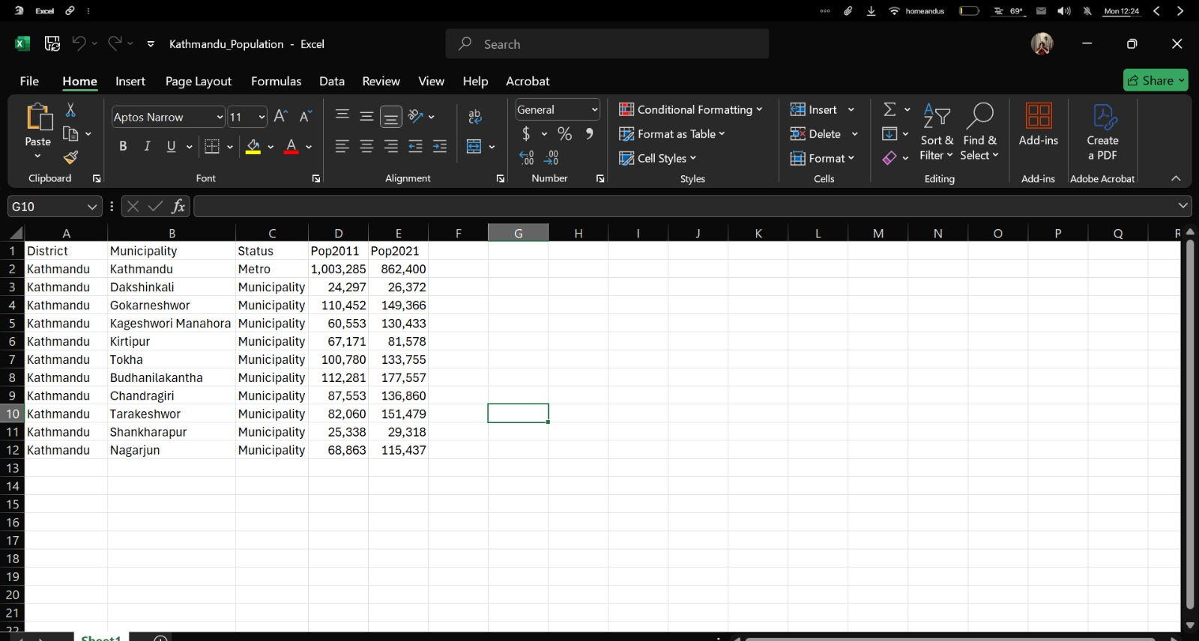
Description: Displays the cleaned population dataset prepared in Excel, showing columns for District, Municipality, Status, Pop2011, and Pop2021.

Screenshot 5: Join Population Table with Municipality Layer
Description: Demonstrates the join between the municipality boundary layer and the population table in ArcGIS.
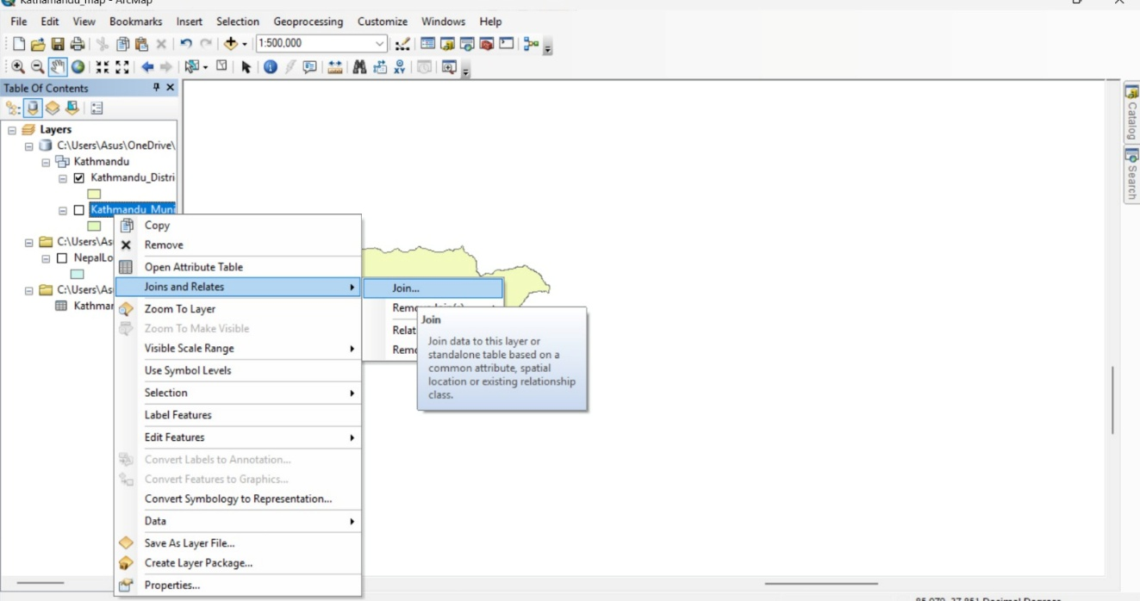
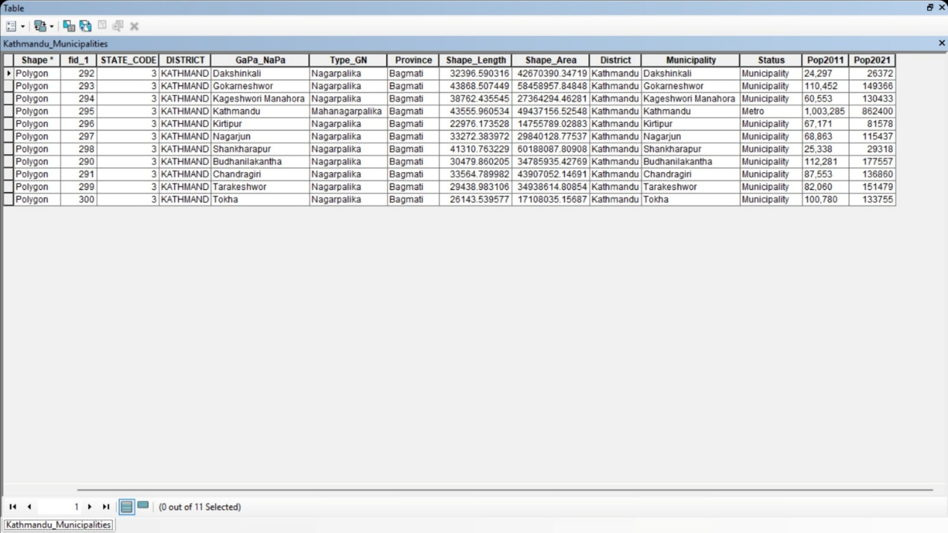

Screenshot 6: Georeferencing Topographic Map
Description: Shows the georeferencing of the topographic map sheet using control points to align raster data with vector layers.
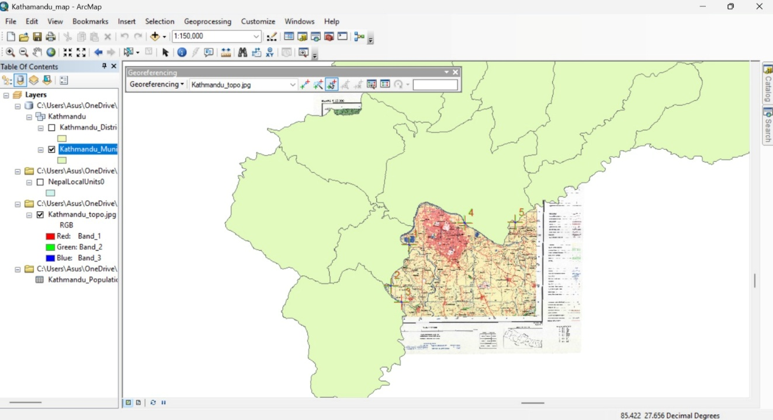

Screenshot 7: Downloaded OSM Layers
Description:
Shows the downloaded OpenStreetMap shapefiles from Geofabrik.

